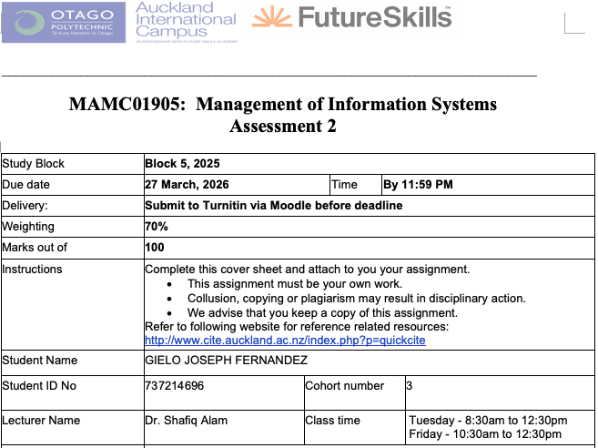
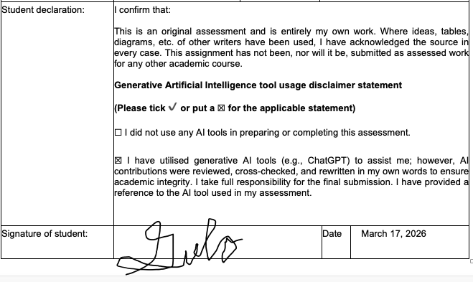
Transformation of Southern Cross Health AI Chatbot

Case Study
Southern Cross is a leading health insurance provider in New Zealand, offering services such as life, health, pet, and travel insurance (Southern Cross Healthcare). The company focuses on delivering accessible and reliable insurance solutions to its members.
Currently, Southern Cross uses Aimee, an AI chatbot that answers customer questions about the health system and insurance terms (McGregor, 2019). While helpful for general inquiries, Aimee’s capabilities are limited and do not provide personalized guidance.
In the future, Aimee could be enhanced to assist with claims, estimate coverage in real time, and offer tailored plan suggestions based on individual profiles and health history. This would transform her into a proactive digital assistant, improving the overall member experience.
To achieve this, Southern Cross will develop and train advanced AI models, integrate comprehensive data governance and security measures (MinterEllison New Zealand, 2025), and adopt Agile methods for continuous improvement..

1.Introduction
In today’s age, chatbots plays a huge part in the success of organizations, not just insurance organizations. Chatbots, also referred to as conversational agents, are interactive intelligent systems that utilize Natural Language Processing (NLP) and machine learning to conduct text or voice-based conversations with humans (Rodríguez Cardona et al., 2021).
In the insurance industry, chatbots are vital for driving digital transformation and helping traditional companies remain competitive against emerging Insurance tech startups (Subhashini et al., 2025). They provide critical 24/7 availability, allowing policyholders to receive immediate clarifications on policy features, premium payments, and claim procedures (Ezhilarasi, 2025).
Southern Cross, New Zealand’s leader in providing health insurance. Southern Cross currently has different cashflow or services such as life insurance, health insurance, pet insurance, and travel insurance(Southern Cross). For Southern Cross, the transformation of the ai chatbot will drive operational efficiency, enhance customer engagement, and provide a strategic competitive advantage in a market increasingly disrupted by Insurance Tech startups (Rodríguez Cardona et al., 2019).
This report will analyse the transformation of AI Chatbot for Southern Cross. Part two will discuss the evolution of AI Chatbot, and the present policies and management regarding the AI Chatbot in Southern Cross. Part three will discuss the current trends and future development of AI Chatbot. Part four will discuss the recommendations and will conclude with the summary in part five.
2. Evolution of Chatbot System at Southern Cross Health
A number of changes have happened in how Southern Cross Healthcare has been manging the policies and the procedures related to their AI chatbot system. Below, we talk about their current state of the art in terms of Managerial policies and procedures.
2.1 Present Management Procedures
Like Southern Cross, insurance companies implement rigorous management procedures to ensure AI chatbots are secure, effective, and compliant with strict financial regulations. These procedures range from long-term strategic planning, continuous technical monitoring, and data security management.
Regarding Long-term Strategic planning, it includes the following:
- Developing a clear AI strategy that corresponds to its specific prerequisites and organizational goals (Haglund, 2024). Management create coherent plans for AI exploration, adoption, and innovation to align technology with long-term business goal (Alkhelb & Alshagrawi, 2025). Management also define the specific customer needs and establish measurable performance goals before full-scale rollouts (Wöger, 2024).
- Instead of a full-scale rollout, management procedures follow a phased strategy to build confidence and minimize risk. This involves starting with small-scale pilot projects in non-critical areas to build organizational confidence before expanding to complex use cases like automated underwriting (Wöger, 2024).
- Planning includes employee upskilling to transition staff from routine insurance processors to become expert in AI. It also ensure seamless handoffs, where a human agent receives the full contextual conversation history if the bot cannot resolve a query (Edgar et al., 2025).
Regarding Continuous Technical Monitoring, it includes the following:
- Functional Testing where the management validates intent and entity recognition to ensure the bot accurately extracts details like policy numbers or beneficiary names. One example is dialogue flow testing to confirm the bot handles topic changing, such as a user changing from a claim query to a policy question mid-conversation, without losing coherence (Pareek, 2024).
- AI specific testing where management mandates testing for Natural Language Processing(NLP) accuracy and implements bias and fairness testing to ensure neutral and equitable responses across demographics (Subhashini et al., 2025).
Regarding Data and Security Management, it includes the following:
- Compliance and Security testing where managers adopt Security by Design, where security is a top priority from the beginning of software development rather than an afterthought (Bokolo & Daramola, 2024). One part of it is applying STRIDE model to identify six categories of threats: Spoofing, Tampering, Repudiation, Information Disclosure, Denial of Service, and Elevation of Privilege (Bokolo & Daramola, 2024).
2.2 Present Management Policies
As the contemporary policies, the current policies relate to the above procedures are outlined here:
- In regards to Developing a clear AI strategy, managers should prioritize tier 1 tasks, routine, high-volume inquiries like policy FAQs, claim status updates, and renewal reminders (Edgar et al., 2025). One example is AXA, where they developed "Data for Good" strategy that aligns AI initiatives with corporate social responsibility (Tase, 2024).
- In regards to Phased Strategy, companies implement guidelines for safe exploration of generative AI. One example is Gjensidige, a Norwegian Insurance Company, opted not to restrict access to tools like ChatGPT but instead provided employees with specific usage guidelines to mitigate risks such as data leaks (Haglund, 2024). Another example is the insurance company Liberty Mutual, where they initiated a chatbot pilot for simple queries that successfully reduced call centre volume (Tase, 2024).
- In regards to Employee Upskilling, roles are redesigned to reallocate human resources away from repetitive tasks and into high-value functions requiring empathy and complex judgment, such as sensitive claims related to death or disability (Edgar et al., 2025). One example is the company Zurich Insurance where they implemented a company-wide "Data Science Academy" to increase data literacy among all employee levels (Tase, 2024).
- In regards Functional Testing, policies require "Human-in-the-loop" systems where a chatbot must automatically detect when it cannot resolve a query and seamlessly transfer the full conversation history to a human agent (Pareek, 2024). Also, regulations like the EU AI Act, management policies mandate that the bot must clearly disclose its identity at the start of an interaction so users know they are not speaking to a human (Pirilä et al., 2022). For Southern Cross, during the development of the chatbot, before any update to Aimee’s conversational engine is pushed to the live environment, management follows a rigorous training protocol (The Spinoff, 2019).
- In regards to Compliance and Security Testing, policies include ensuring that AI chatbot has security features such as end-to-end encryption for transmitted data (Bokolo & Daramola, 2024), role-based access to ensure users only interact with data relevant to their department (Bokolo & Daramola, 2024), log files for auditing and traceability, which is critical for meeting regulatory disclosure requirements (Pareek, 2024).
- In regards to AI Specific Testing, policies include mandates that all AI models must undergo regular audits for bias and accuracy to prevent model degradation over time (Pareek, 2024). Policies also include that AI driven decisions, particularly those affecting claims or premiums, must be accompanied by a human-readable rationale that can be audited by regulators or explained to customers (Tase, 2024).
3. Current Trends and Future Developments
There are a number technology that is up for adoption in term AI Chatbot in the domain of hardware, software, network, and data. Some of such technology is analysed below that well suit the needs of Southern Cross Healthcare.
3.1 Current Trends in AI Chatbot
Currently, the Southern Cross Health’s chatbot, Aimee, functions primarily as a virtual crew member for Southern Cross. Her main job is to make health insurance less confusing by explaining how the NZ health system works and the value of different plans. While she uses machine learning to get better over time, she is not yet the fully integrated co-pilot that can manage your entire policy or handle your money directly (McGregor, 2019).
However, today, chatbots are driven by many advancements today, it is listed in the following:
- Use of Natural Language Processing (NLP) and Large Language Models (LLMs). A dominant trend is the hybrid operational model, where chatbots handle basic routine tasks (policy FAQs, status updates) and human agents manage complex, high-value, or emotionally sensitive cases (Pirilä et al., 2022).
- Use of Retrieval-Augmented-Generation to ensure chatbot responses are grounded in an insurer's verified document folders rather than general internet knowledge, which significantly reduces the risk of "hallucinations" or fake information and protects data privacy (Vuohelainen, 2024).
- Use of chatbots for lead generation, cross-selling, and up-selling by analyzing customer data in real-time to offer personalized recommendations during a session (Götzer, 2024).
- Use of chatbots to handle and settle simple, high-frequency claims (like property damage or stolen items) in seconds. One example is the insurance company Lemonade, Inc where they use “AI Jim" system tin settling claims. “AI Jim” can settle claim in as little as three seconds (Tase, 2024).
3.1 future developments in AI Chatbot
Future developments of AI Chatbot in the insurance industry signify a move toward a proactive, hyper-personalized, and deeply integrated ecosystem where bots act as Real-Time Data Analyst for both customers and employees (O’Connell et al., 2025).
More future developments of AI Chatbot is discussed in detail in the following:
- Leveraging IoT and sensor data from smart homes and vehicles to alert policyholders to hazards before a loss occurs, such as detecting water leaks or suggesting roof reinforcements before storm seasons (William, 2025).
- Simulation of complex disaster scenarios more accurately than traditional models, allowing insurers to Price catastrophe risk better and optimize response strategies (Dolzhich, 2024).
- Move away from standard offerings toward individualized, real-time insurance solutions. By 2030, it is predicted that 50% of all insurance products will be dynamically priced and personalized in real-time based on actual behavior data from telematics and wearables (Tase, 2024).
- Act as advisors, rewarding policyholders with lower premiums for safe driving habits or healthy lifestyles tracked through connected devices (Dolzhich, 2024).
- Future chatbots will be trained to detect and appropriately respond to emotional cues and voice tones, providing more empathetic support during critical life events like illness or death (Pareek, 2024).
While the capabilities of Southern Cross’s Aimee are lagging behind, we can get it up to date with the current capabilities of chatbots as well as future capabilities.
3. 3 Transition of Southern Cross Chatbot from current to goal state
Currently, the capabilities of Southern Cross’s Aimee is listed in the following:
- Answer common questions such as the value of health insurance and how the health system works. Aimee can also define specific industry terms, such as "pre-existing conditions," in easy-to-understand language. (Paredes, 2019).
- Acts as a virtual "crew member," providing information on insurance value and processes at any time via desktop, tablet, or smartphone (McGregor, 2019).
- Aimee can process and interpret what is said to her during a conversation and respond accordingly, rather than just matching keywords (McGregor, 2019).
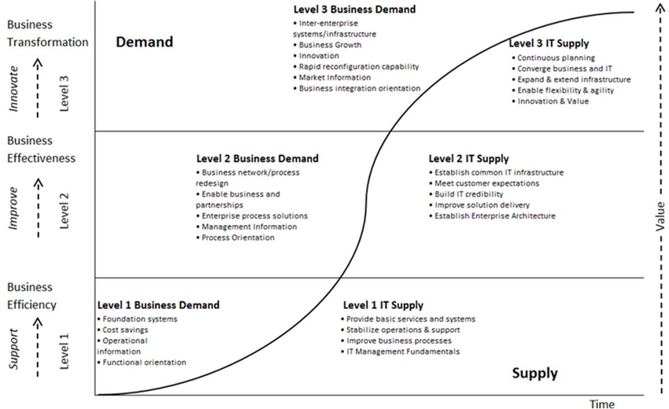
Figure 1 Merlyn's Maturity Model
Using the Merlyn’s Maturity Model, which is shown in the image below (Müller et al., 2015). We can check what level is Aimee currently at. We know that it is not level one since Aimee wasn’t just created to fulfil a request, Aimee was created to solve a business challenge, helping customers in understanding difficult insurance jargon and are too embarrassed to call/ask an insurance advisor/broker (MacManus, 2019). This is why it is at level two. We also know it is not level three since we know that while Aimee is innovative, Aimee hasn't transformed yet the core commercial structure of Southern Cross in a way that creates a new, entirely tech-driven market advantage (McGregor, 2019).
With the vision of Southern Cross to deliver healthier years for more New Zealanders, and inspire people to advance their health and wellbeing and live well for longer (Southern Cross, 2023). We can use TOGAF or Zachman to transform Southern Cross Aimee to the future/goal states mentioned above.
When we use TOGAF, we need to identify first the architecture vision or the understanding between current state and goal state (Rybalchenko, 2024). We can say that for Aimee, the goal automate some processes, reduce claim submission time, and personalize customer service (Anindita & Huda, 2025).
Second is to identify the business architecture which is to map out the business processes that the chatbot will handle to identify areas for optimization. We can say that for Aimee, the goal is to be able to analyse processes like claim submission, insurance registration, and promotion to see where the chatbot can automate routine tasks (Anindita & Huda, 2025).
Third is the Information Systems Architecture, which is to define the data and application architecture (Tan, 2023). For the data architecture, we focus on data availability and quality, we can use techniques like Retrieval-Augmented Generation to allow the chatbot to access up-to-date, organization-specific data (e.g., policy manuals) instead of relying solely on pre-trained information (Vuohelainen, 2024). For the application architecture, we should ensure the chatbot can call backend APIs to check a customer's account status or billing information in real-time (Crosley et al., 2023).
Fourth is the Technology Architecture, which is to identify the hardware and software needed to support advanced AI features (Maketas & Zisopoulos, 2013). For Aimee, we choose the appropriate Large Language Model (LLM), such as GPT-4o or BERT, and selecting frameworks like LangChain for prompt management (Brancati, 2025). For the infrastructure, deploying technologies like Apache Kafka for real-time query processing and cloud-based systems like AWS and Google Cloud to ensure scalability (Bello, 2025).
Fifth is the Opportunities, Solutions, and Migration. This is where we focus on the practical transition from the current state to the improved goal state (Pisoni et al., 2021). For Aimee, we don't upgrade everything at once. Starting with small-scale pilot projects in non-critical areas to build organizational confidence before expanding to complex tasks like automated underwriting (Tase, 2024). Here we also define KPIs early, such as customer satisfaction (CSAT) or first-contact resolution rates, to measure the improvement of the chatbot over time (Pant, 2025).
Sixth is the Governance and Change Management, where we ensure that the implementation remains compliant and the organization can adapt to the rapid evolution of AI technology (Vuohelainen, 2024). Here we establishing AI Ethics Review Boards and implementing automated checks to ensure real-time adherence to regulations like GDPR, HIPAA, and the EU AI Act (Vuohelainen, 2024). Here we also implement procedures for quarterly audits to detect model drift or algorithmic bias in the chatbot's decision-making (Pareek, 2024). We also ensure that the architecture is flexible enough to allow for the quick replacement of LLMs as new, more efficient models emerge (Wöger, 2024).
4. Recommendations
Lorem ipsum
5. Summary and Conclusion
Lorem ipsum
6. References
Alkhelb, A. A., & Alshagrawi, S. (2025). Role of artificial intelligence in healthcare insurance: Systematic literature review. Exploration of Digital Health Technologies, 3. https://doi.org/10.37349/edht.2025.101145
Anindita, T., & Huda, M. Q. (2025). TOGAF ADM Framework Design at Private Insurance Company PT Tugu Pratama. Syarif Hidayatullah State Islamic University. https://www.uinjkt.ac.id
Bello, S. (2025). Customer-Facing Financial Chatbots in Insurance. ResearchGate. https://www.researchgate.net/publication/394530963_Customer-Facing_Financial_Chatbots_in_Insurance
Bokolo, Z., & Daramola, O. (2024). Elicitation of security threats and vulnerabilities in Insurance chatbots using STRIDE. Scientific Reports, 14(1). https://doi.org/10.1038/s41598-024-68791-z
Brancati, I. (2025). Generative Artificial Intelligence for Insurance: Developing a chatbot for Multi-Document Summarization of Insurance Products. Politecnico di Torino.
Crosley, N., Indrajit, R. E., & Dazki, E. (2023). TOGAF Framework For an AI-enabled Software House. Sinkron : Jurnal Dan Penelitian Teknik Informatika, 7(2), 1142–1152. https://doi.org/10.33395/sinkron.v8i2.12390
Dolzhich, E. (2024). The Role of AI and Machine Learning in Shaping the Future of Insurance.
Edgar, T., Fletcher, N., & Lane, V. (2025). The Transformative Benefits and Implementation Challenges of Conversational Artificial Intelligence Chatbots in Enhancing Efficiency and Customer Experience within Modern Insurance Operations.
Ezhilarasi, A. (2025). AI chatbot interactions and customer satisfaction in the insurance sector: Evidence from Star Health & Allied Insurance Company Limited in Chennai.
Götzer, J. (2024). Engineering and User Experience of Chatbots in the Context of Damage Recording for Insurance Companies. University of Stuttgart.
Haglund, S. (2024). Identifying barriers to increased AI in the insurance industry: A case study [Master’s thesis, KTH Royal Institute of Technology]. http://www.diva-portal.org/smash/record.jsf?pid=diva2:1897535
MacManus, R. (2019). The digital human who wants to talk to you about your health insurance. The Spinoff. https://thespinoff.co.nz/partner/12-12-2019/the-digital-human-who-wants-to-talk-to-you-about-your-health-insurance
Maketas, D., & Zisopoulos, I. (2013). Integration of TOGAF and SABSA on the Increased Effectiveness and Security of a Software Development Life Cycle, in the Context of a Spinoff Company [Luleå University of Technology]. https://www.diva-portal.org
McGregor, A. (2019, November 21). Human touch meets AI on health insurance frontline. Southern Cross NZ. https://www.southerncross.co.nz/news/2019/health-insurance-ai-digital-human
MinterEllison New Zealand. (2025, November 10). AI risks: What do insurers want to know about your use of AI? MinterEllison NZ Insights. https://www.minterellison.co.nz/insights/ai-risks-what-do-insurers-want-to-know-about-your
Müller, S., Holm, S., & Søndergaard, J. (2015). Benefits of Cloud Computing: Literature Review in a Maturity Model Perspective. Communications of the Association for Information Systems, 37. https://doi.org/10.17705/1CAIS.03742
O’Connell, M., Bennett, K., & Ward, P. (2025). The Conversational Revolution in Insurance: A Mixed-Methods Study on the Efficacy and Implementation Challenges of Chatbots for Real-Time Data Analysis in Insurance Underwriting, Claims, and Risk Management. ResearchGate. https://www.researchgate.net/publication/396509124_The_Conversational_Revolution_in_Insurance_A_Mixed-Methods_Study_on_the_Efficacy_and_Implementation_Challenges_of_Chatbots_for_Real-Time_Data_Analysis_in_Insurance_Underwriting_Claims_and_Risk_Managem
Pant, P. (2025). Revolutionizing Insurance Data Modernization: Enhancing Property and Casualty Insurance with Cloud Solutions, Data Lakes, and Real-Time Reporting to Propel Advanced Analytics, Ensure Unified Governance and Compliance, and Foster Innovation and Experimentation. Journal of Computational Analysis and Applications, 34(5), 187–200.
Paredes, D. (2019). Digital human joins customer service team at Southern Cross Health Society. CIO. https://www.cio.com/article/201607/digital-human-joins-customer-service-team-at-southern-cross-health-society.html
Pareek, C. S. (2024). Beyond Automation: A Rigorous Testing Framework for Reliable AI Chatbots in Life Insurance. International Journal of Science and Research (IJSR), 13(6), 1485–1493.
Pirilä, T., Salminen, J., Osburg, V.-S., Yoganathan, V., & Jansen, B. J. (2022). Investigating the Role of Technical and Process Quality in Chatbots: A Case Study from the Insurance Industry. 1485–1494. https://hdl.handle.net
Pisoni, G., Molnár, B., & Tarcsi, Á. (2021). Data Science for Finance: Best-Suited Methods and Enterprise Architectures. Applied System Innovation, 4(3), 69. https://doi.org/10.3390/asi4030069
Rodríguez Cardona, D., Janssen, A., Guhr, N., Breitner, M. H., & Milde, J. (2021). A matter of trust? Examination of chatbot usage in insurance business.
Rodríguez Cardona, D., Werth, O., Schönborn, S., & Breitner, M. H. (2019). A mixed methods analysis of the adoption and diffusion of chatbot technology in the German insurance sector.
Rybalchenko, A. (2024). Integration von KI als Designelement auf Unternehmensarchitekturebene für Finanzinstitute. In Wirtschaftsinformatik.
Southern Cross. (2023). Community Impact Report 2023. Southern Cross. https://www.southerncross.co.nz/-/media/group/community/community-impact-report-2023/community-impact-report-2023-final.pdf
Southern Cross. About Southern Cross. https://www.southerncross.co.nz/about-southern-cross
Subhashini, V., Anusha, T., Swathi, M., & Sridhar, K. (2025). AI powered chatbot in health insurance.
Tan, L. H. (2023). Consumer reaction to the use of artificial intelligence chatbot on distribution of general insurance in Singapore [Singapore Management University]. https://ink.library.smu.edu.sg
Tase, J. (2024). Generative AI in Insurance Industries: Transforming Workflows and Enhancing Customer Experience. International Research Journal of Engineering Science Technology and Innovation, 11(7), 512–519.
Vuohelainen, R. (2024). ARTIFICIAL INTELLIGENCE (AI) AND ROBOTIC PROCESS AUTOMATION (RPA) IN THE INSURANCE BUSINESS. Centria University of Applied Sciences.
William, B. (2025). From Claims to Chatbots: How Digitalization is Reshaping the Insurance Ecosystem.
Wöger, M. (2024). The future of customer service chatbots in the Austrian finance and insurance industry: An analysis of expert’s and generation z’s perspectives on addressing the limitations of chatbots. FH Joanneum.

